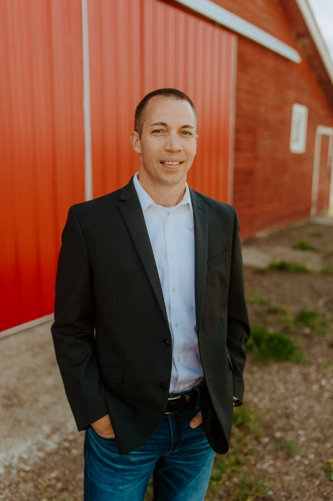
Jedd Lekvold's
We would like to honor the success story of Jedd Lekvold. In Scobey, Montana, on Christmas Day 1980, Jedd was born. He was "the best Christmas present ever," according to his mother. (These were most certainly not Jedd's words.) After receiving his high school diploma in the spring of 1999 (Go Spartans!), Jedd went on to attend MSU-Billings and graduated in the winter of 2003 with a bachelor’s degree in finance. (One extra semester owing to his procrastination). Throughout his college years, Jedd worked part-time in the warehouse at Western Builders Supply.

After earning his degree, he accepted a position as a sales representative for Western Builders Supply, where he sold fasteners. While working for WBS, Jedd traveled to lumberyards in Montana, Wyoming, North and South Dakota, and Nebraska. In May of 2005, Jedd returned home to Scobey and began building a family of his own. He is married to his beautiful wife, Kiki, who was born and raised in Scobey. Kiki is an insurance agent and the two of them have been blessed with four children: Gracee (20), Claire (14), Blake (13), and Nate (10). In October 2005, Jedd was hired as a milk man by his brother-in-law, who owned a local dairy distribution company, where he distributed dairy and food products to numerous stores.

In July of 2007, Jedd was hired as a lender by Independence Bank and has worked for IB ever since. He maintains the title of Assistant Vice President of AG Lending and is proud to work for an organization that takes pride in their experience and knowledge of Agriculture. Jedd is grateful for the Ag community and looks forward to the future!

As a very active community member, Jedd has also taken on several roles for both the boys' and girls' high school basketball teams, the football team, and is presently the head girls’ basketball coach at Scobey High School. Jedd is a member of the Montana Coaches Association and has been part of various other organizations such as: Scobey Alumni Foundation Inc., Scobey Baseball, Daniels County Chamber of Commerce, Hospital Foundations, and Plainsmen

Matt Wertheimer
The second individual we would like to recognize is the well-known Matt Wertheimer. Matt grew up on his family ranch in the little town of Utica, Montana. He attended college at Montana State University and graduated in 1998 with a degree in Agricultural Business. Upon receiving his degree, Matt went back home to work on his family ranch for five years, before being hired by Independence Bank in 2003 as a Lender Trainee. In Matt’s entire life, he has only had two employers: his dad and Independence Bank.

In his 20 years, he has progressed through the positions of Lender Trainee, Senior Loan Officer, Vice President, Senior Vice President, and into his most recent position as Chief Lending Officer. The relationships Matt has forged with clients and coworkers during his time at Independence Bank are what he is most proud of, and these relationships have only grown stronger since he began.

It should be noted that in addition to his genuine devotion and love for IB, Matt is also quite active in the Havre community. He is President of both the Friends of Beaver Creek Park and the Havre Chamber of Commerce. He serves as Chairman for the St. Jude’s Thaddeus School Foundation, and recently joined the MSU-Northern Foundation Board. Prior to his resignation in 2017, he also spent 12 years on the MSUN Rodeo Board (although it must be known that he still "stays active flipping burgers whenever they need a hand”). His steady commitment to every endeavor he undertakes is what helps this company grow and succeed. He considers working for the Bank to be a blessing in his life and is PROUD to have worked for one great organization for so many years!

